

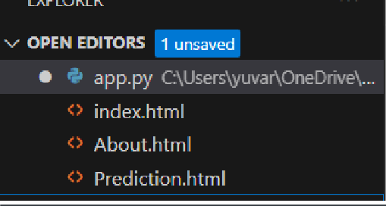
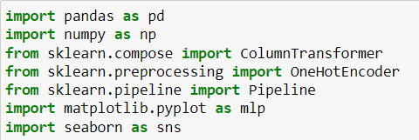
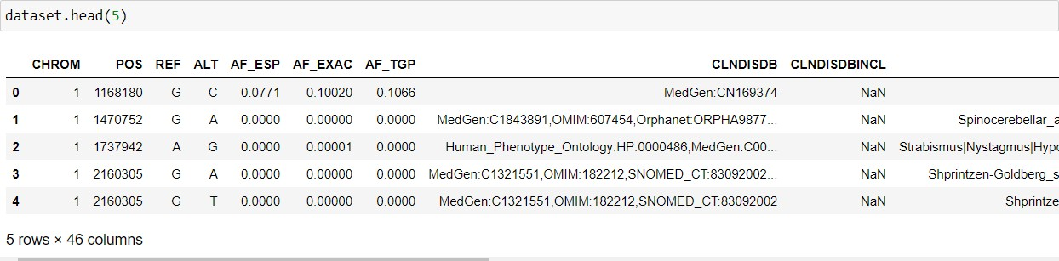
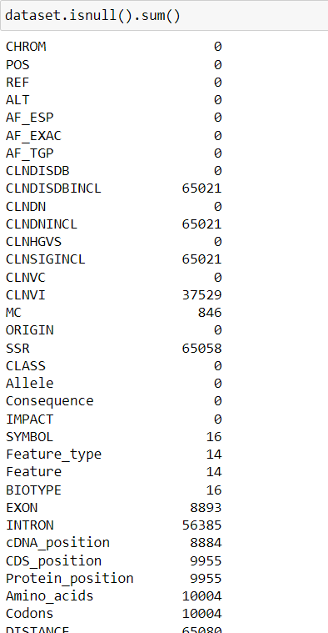
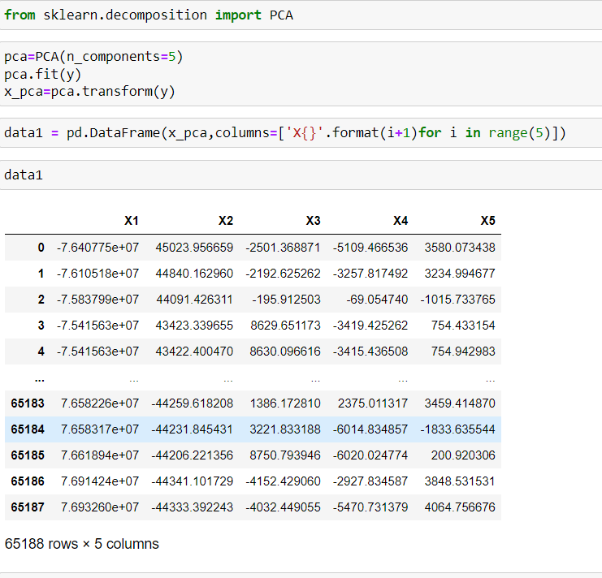
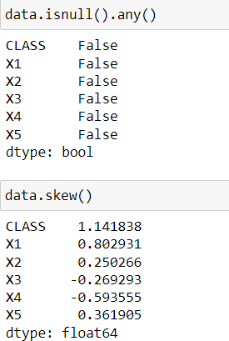
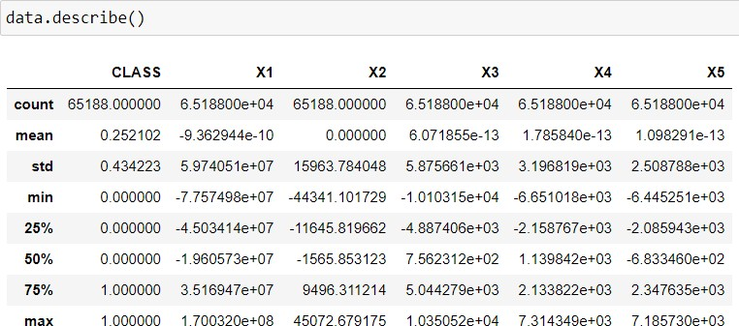
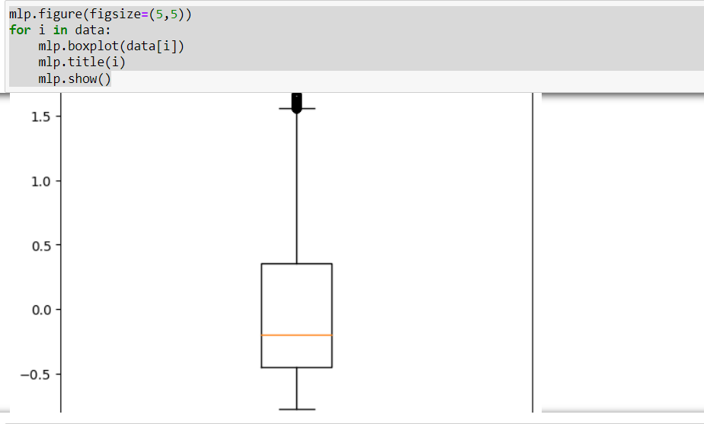
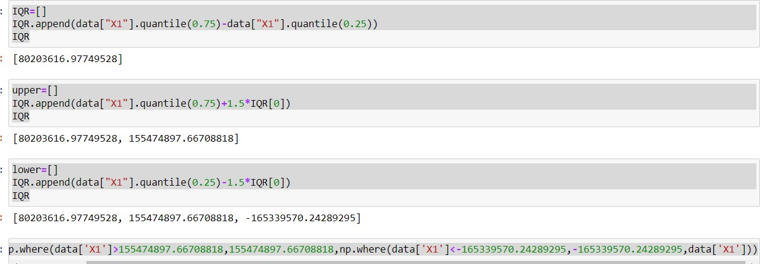
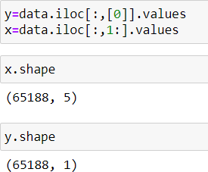
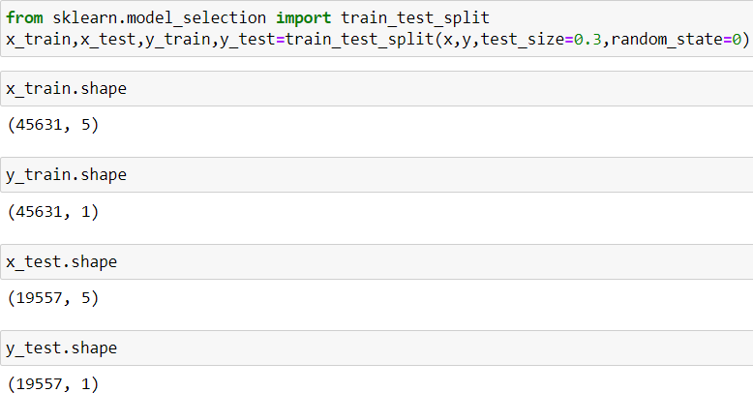
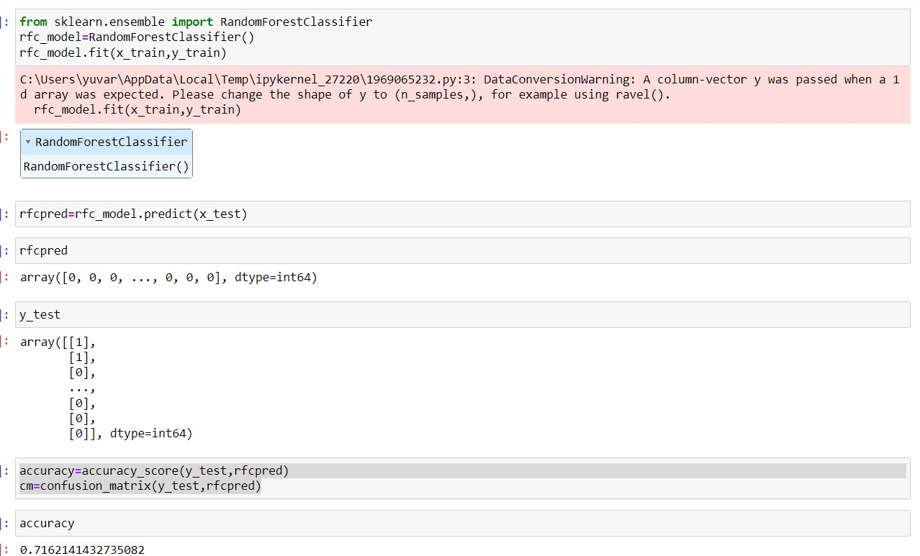
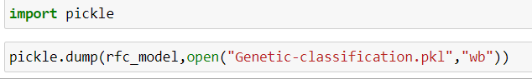
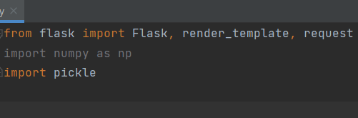
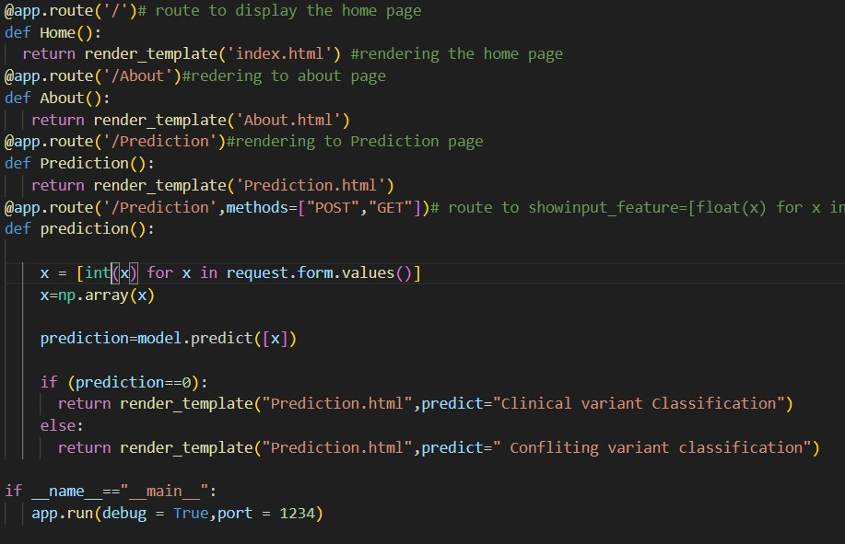
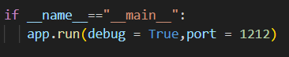
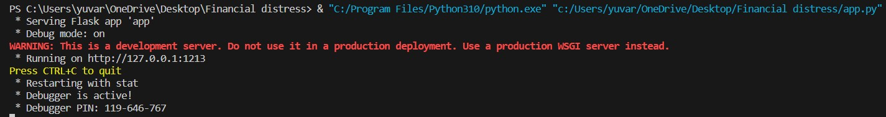
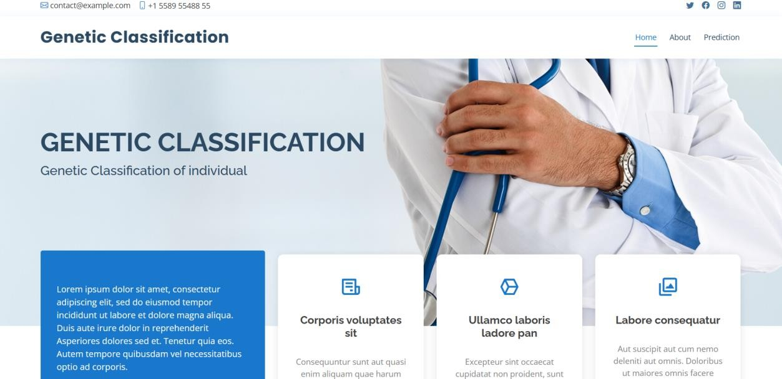
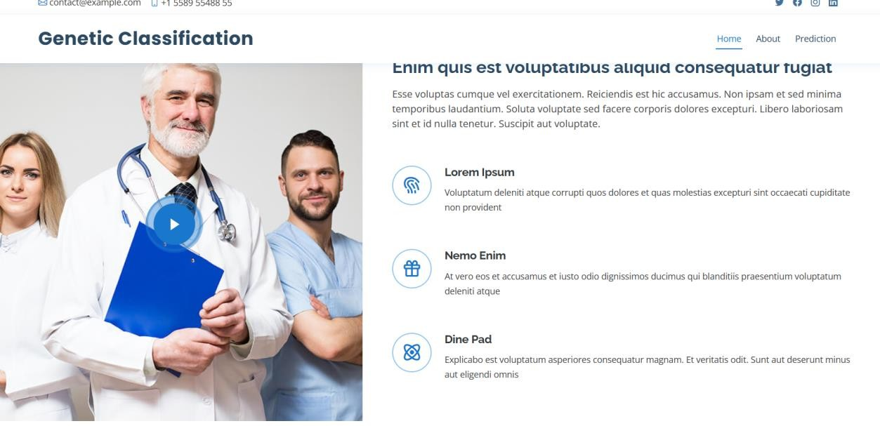
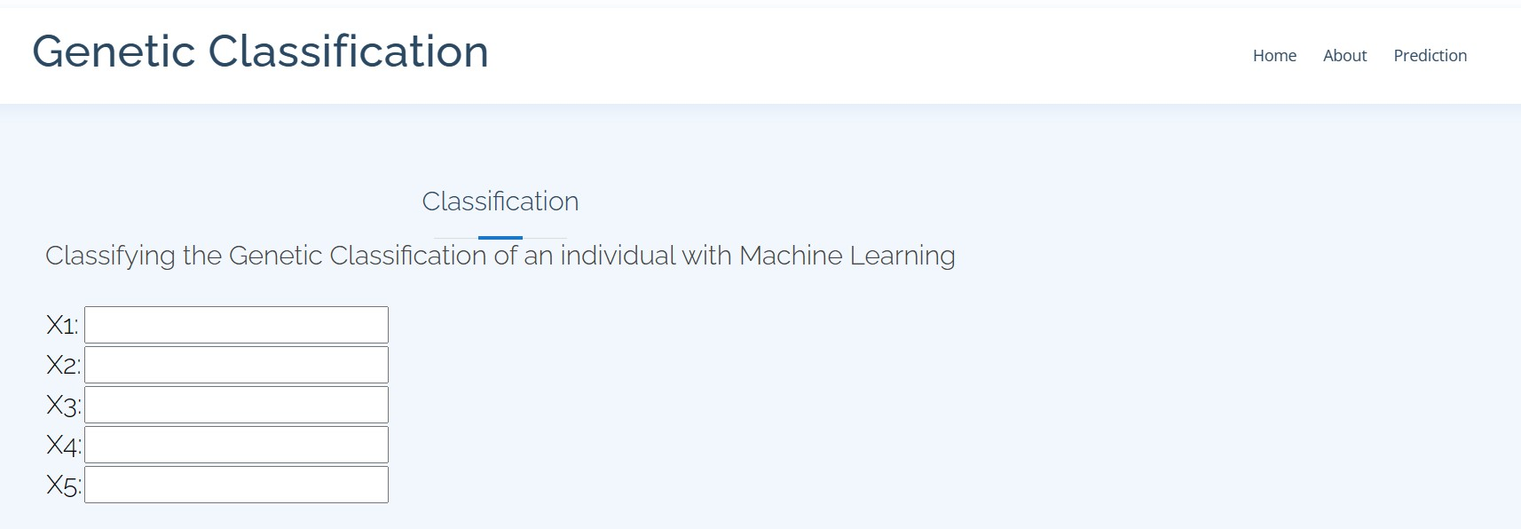

Stress Analysis of Social Media Post by Machine learning

SmartInternz
www.smartinternz.com
Stress Analysis of Social Media Post by Machine learning :

Context - We live in an era where there is a surplus of information flowing in every second. Sometimes this leads to stress. ☹️Too much stress can negatively impact our health and may lead to headaches, high blood pressure, heart problems, diabetes, skin conditions, asthma, arthritis, depression, and anxiety

Content - A data-set of lengthy multi-domain social media data for identifying stress from five different categories of Reedit communities

Technical Architecture:

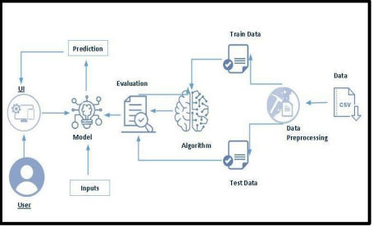

Project Flow:
- User interacts with the UI to enter the input.
- Entered input is analyzed by the model which is integrated.
- Once model analyses the input the prediction is showcased on the UI To accomplish this, we have to complete all the activities listed below,
- Define Problem / Problem Understanding
  - Specify the Missing-Value, Migrants problem
  - Literature Survey
- Data Collection & Preparation
  - Collect the data-set
  - Data Preparation
- Exploratory Data Analysis
  - Visual Analysis
- Model Building
  - Performing data Prepossessing
  - Performing data Vectorizer Techniques
  - Apply the Machine learning algorithms
- Performance Testing & Hyper-parameter Tuning
  - Testing model with multiple evaluation metrics
  - Comparing model accuracy
- Model Deployment
  - Save the best model
  - Integrate with Web Framework

- Project Demonstration & Documentation
  - Project Documentation-Step by step project development procedure

Prior Knowledge:
You must have prior knowledge of following topics to complete this project.
- ML Concepts
  - Supervised learning: https://www.javatpoint.com/supervised-machine-learning
  - Unsupervised learning: https://www.javatpoint.com/unsupervised-machine-learning
- Decision tree: https://www.javatpoint.com/machine-learning-decision-tree-classification- algorithm
- Random forest: https://www.javatpoint.com/machine-learning-random-forest-algorithm
- Xgboost: https://www.analyticsvidhya.com/blog/2018/09/an-end-to-end-guide-to- understand-the-math-behind-xgboost/
- Evaluation metrics: https://www.analyticsvidhya.com/blog/2019/08/11-important-model- evaluation-error-metrics/
- Flask Basics : https://www.youtube.com/watch?v=lj4I_CvBnt0

Project Structure:
- Create the Project folder which contains files as shown below:

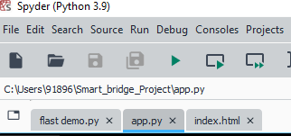

We are building a flask application which needs HTML pages stored in the templates folder and a python script app.py for scripting.
- My_model.pkl is our saved model. Further we will use this model for flask integration.
- Data Folder contains the Data-set used
- The Notebook file contains procedure for building the model.

Milestone 1: Define Problem / Problem Understanding:

Activity 1: Specify the Classification problem : We live in an era where there is a surplus of information flowing in every second. Sometimes this leads to stress so here we have to Check the sentiment of the post and Comment of their posts and we have to predict or Identify He or She is In Stress or No Stress.

Conflicting classification has been assigned to the LABLE column. It is a binary representation of whether Based on his/her Comment he or she is in Stress or not, where 0 NOT Stress classifications and 1 represents Stress classifications.

Activity 2: Literature Survey :

The objective is to predict The Person is In stress or not Stress To find the Solution why he or she is in Stress what are the Reason And how we can help them so that in future it won't repeat for them based on there social media post and and comment we will fetch information and then we will do sentimental Analysis on the text and then we will able to predict that he or she is in Stress or not Stress.

Milestone 2: Data Collection & Preparation:
Activity 1: Collect the data-set

There are many popular open sources for collecting the data. Eg: kaggle.com, UCI repository, etc.
In this project we have used .csv data. This data is downloaded from kaggle.com. Please refer to the link given below to download the data-set.
Link: https://www.kaggle.com/datasets/ruchi798/stress-analysis-in-social-media?resource=download
As the data-set is downloaded. Let us read and understand the data properly with the help of some visualization techniques and some analyzing techniques.
Activity 1.1: Importing the libraries:Import the necessary libraries

as shown in the image. (optional) Here we have used visualization style as five thirtyeight.

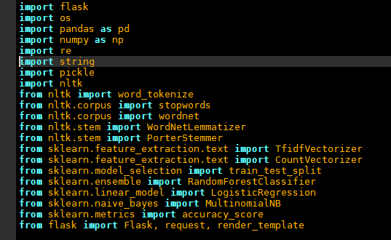

Activity 1.2: Read the Dataset :
Our data-set format might be in .csv, excel files, .txt, .json, etc. We can read the dataset with the help of pandas. In pandas we have a function called read_csv() to read the data-set. As a parameter we have to give the directory of the csv file.

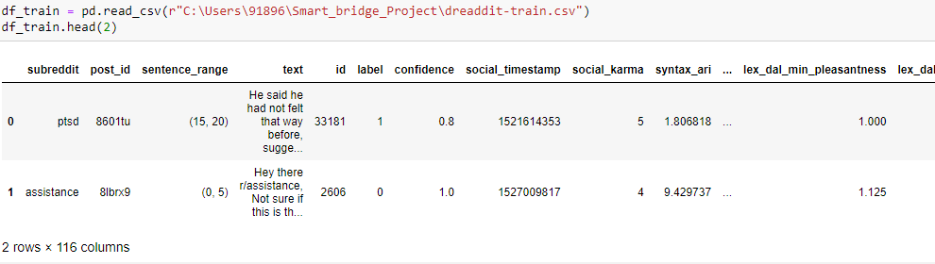

Activity 2: Data Preparation:As we have understood how the data is, let's per-process the collected data. The download data set is not suitable for training the machine learning model as it might have so much randomness so we need to clean the data-set properly in order to fetch good results. This activity includes the following steps.

- Handling missing values
- Note: These are the general steps of per-processing the data before using it for machine learning. Depending on the condition of your data-set, you may or may not have to go through all these steps.
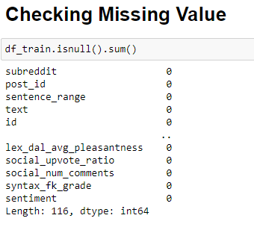

We have nearly 116 columns ,for that we cant do flask so we have to take the most important
take the most important columns that we will do in feature Engineering

Activity 2.1: Handling missing values:

- For checking the null values, df.isna().any( ) function is used. To sum those null values we use .sum() function. From the below image we found that there are no null values present in our dataset. So we can skip handling the missing values step.

Milestone 3: Exploratory Data Analysis Activity 1: Descriptive statistical
Descriptive analysis is to study the basic features of data with the statistical process. Here pandas has a worthy function called describe. With this describe function we can
understand the unique, top and frequent values of categorical features. And we can find mean, std, min, max and percentile values of continuous features.
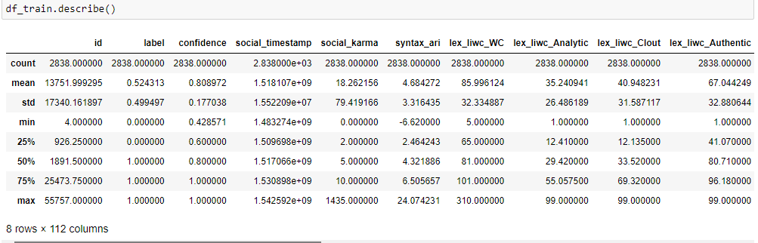

Activity 2: Visual analysis

Visual analysis is the process of using visual representations, such as charts, plots, and graphs, to explore and understand data. It is a way to quickly identify patterns, trends, and outliers in the data, which can help to gain insights and make informed decisions
In the below plot ,it will indicate that in which “Region ” having high number of missing.

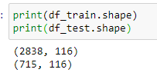
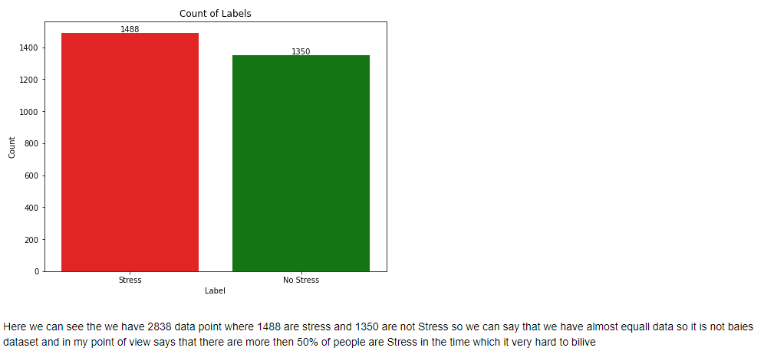

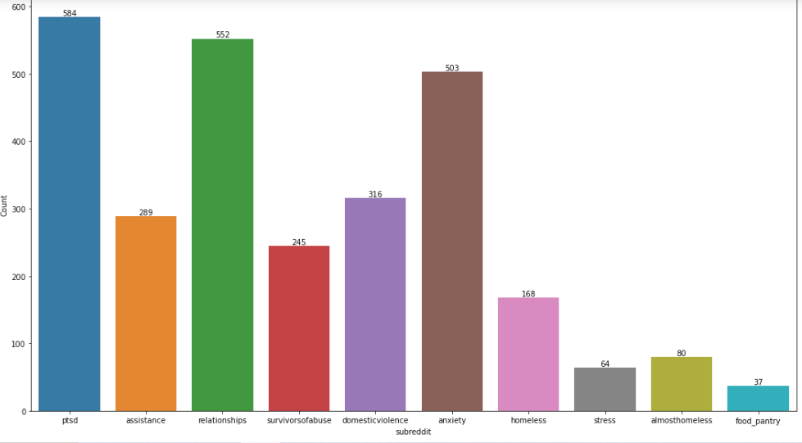

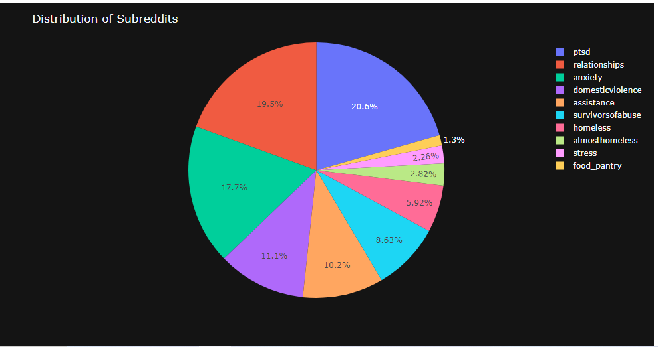
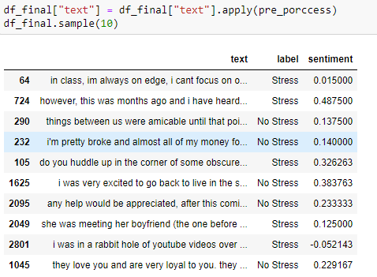
Final Data – Set

Spliting of the data

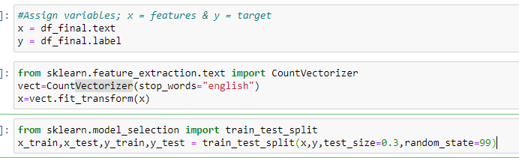

Milestone 4: Model Building
Activity 1: Training the model in multiple algorithms
Now our data is cleaned and it’s time to build the model. We can train our data on different algorithms. For this project we are applying three classification algorithms. The best model is saved based on its performance.
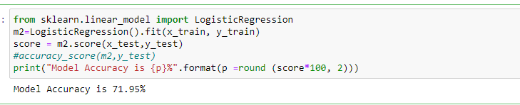

Milestone 6: Model Deployment Activity 1: Save the best model
Saving the best model after comparing its performance using different evaluation metrics means selecting the model with the highest performance. This can be useful in avoiding the need to retrain the model every time it is needed and also to be able to use it in the future.

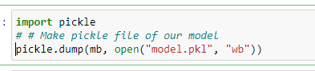

Activity 2: Integrate with Web Framework:In this section, we will be building a web application that is integrated to the model we built. A UI is provided for the uses where he has to enter the values for predictions. The enter values are given to the saved model and prediction is showcased on the UI.
This section has the following tasks
Building HTML Pages
- Building server-side script
- Run the web application

Activity 2.1: Building Html Page:
For this project create HTML file namely
- Index10.html
and save them in the templates folder.

Activity 2.2: Build Python code:
Import the libraries

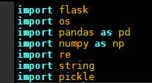
Load the saved model. Importing the flask module in the project is mandatory. An object of Flask class is our WSGI application. Flask constructor takes the name of the current module ( name ) as argument.

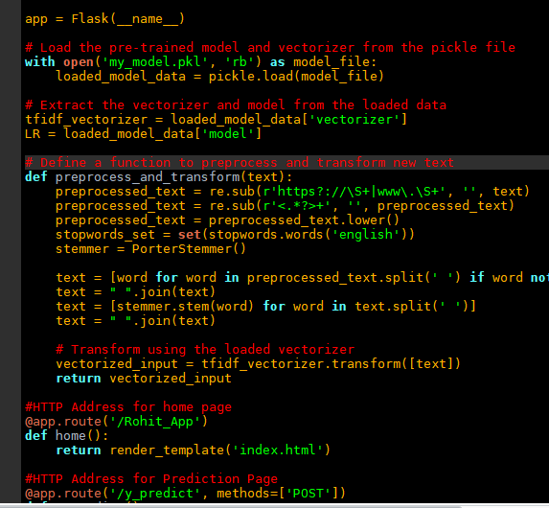
Here we are routing our app to predict() function. This function retrieves all the values from the HTML page using Post request. That is stored in an array. This array is passed to the

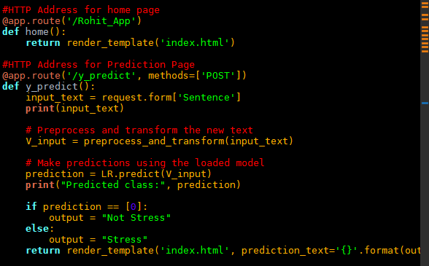
model.predict() function. This function returns the prediction. And this prediction value will be rendered to the text that we have mentioned in the Index.html page earlier.
Main Function:

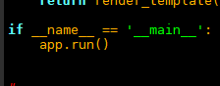
Activity 2.3: Run the web application
- Open anaconda prompt from the start menu
- Navigate to the folder where your python script is.
- Now type “python app.py” command
- Navigate to the localhost where you can view your web page.
- Click on the predict button from the top left corner, enter the inputs, click on the submit button, and see the result/prediction on the web.

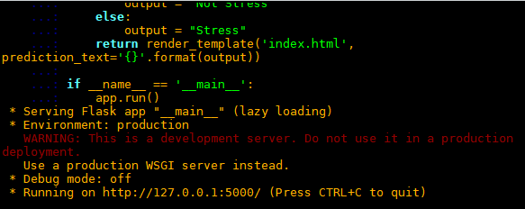
Now,Go the web browser and write the localhost url (http://127.0.0.1:5000) to get the index10.html
Home page:
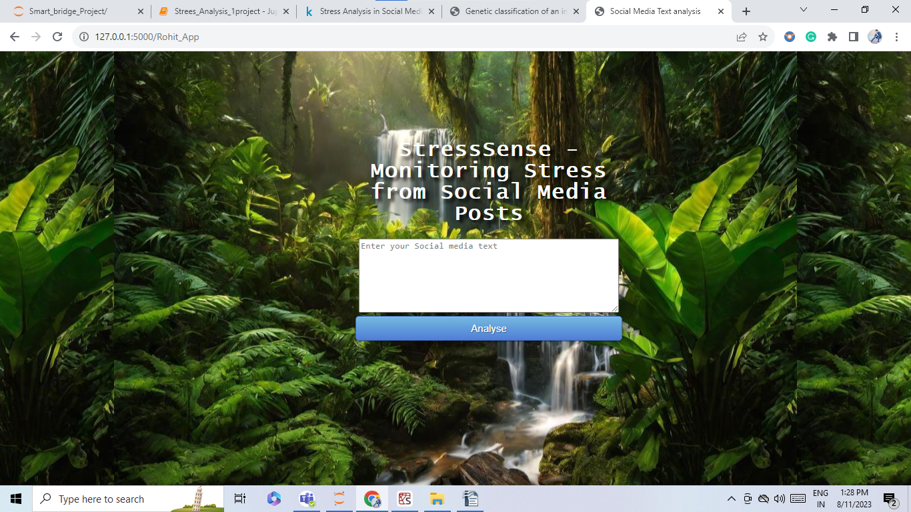
Prediction:
